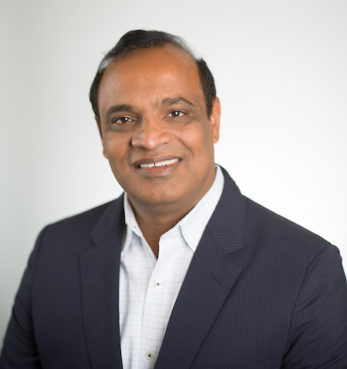
DAMODAR RAO GUMMADAPU
Co-Founder and Chairman, Techwave
Damodar Rao Gummadapu is a veteran IT & engineering solutions leader, serial entrepreneur, and strategic tech investor with over two decades of experience facilitating digital transformation journeys for companies across the globe. His solid entrepreneurial streak has enabled him to build multiple organizations and nurture them profitably. Damodar brings extensive experience in leading global enterprises like Techwave and MosChip, while also pivotal in developing innovative next-gen tech solutions for the market.

He has been a vital beacon of guidance for Techwave and has been driving Techwave’s growth story. His enterprising nature has inspired Techwave’s leaders to function independently and fulfill his vision of fostering a prolific and people-focused organization. As an astute businessman, Damodar propelled Techwave to new heights by bridging the gap between market requirements with next-gen, purpose-led innovation. By identifying key expansion areas, he fostered Techwave’s capabilities in a way that adds value to businesses from a holistic perspective.

Damodar has always been focused on creating a service pipeline that caters to the requirement of future-proofing organizations. From being an active investor in Moschip to driving the company’s turnaround story as a CEO, Damodar wielded his experience and foresight to establish an organization that has reached new heights and even became a very specialized semiconductor solutions provider.

He has previously been in key leadership positions in companies like KPMG and Deloitte. He drew deep insights on how mid-sized businesses drive their customer acquisition and business development across different domains. Damodar has leveraged his expertise in the IT consulting space and his inherent business acumen to catalyze his vision to be a tech entrepreneur and introduce novel solutions in the IT field.

With a strong finance background and pioneering business spirit, Damodar went on to implement industry best practices and redefined service benchmarks in the IT & engineering solutions space through Techwave.

